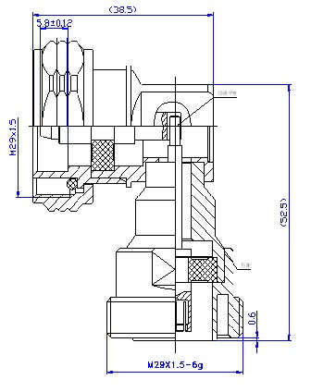
7/16 DIN Male to 7/16 DIN Female Right Angle Connector Adaptor
Interface
According to |  | IEC 60169-4
Electrical
Characteristic Impedance |  | 50 ohm
Frequency Range |  | DC-7.5GHz
VSWR |  | ≤1.10@DC-3000MHz
Dielectric Withstanding Voltage |  | ≥4000V RMS,50Hz,at sea level
Dielectric Resistance |  | ≥10000MΩ
Contact Resistance |  | Center Contact ≤0.4mΩ
 |  | Outer Contact ≤1 mΩ
Mechanical
Durability |  | Mating cycles ≥500
Material and plating
 | Material | Plating
Body | Brass | Tri-Metal
Insulator | PTFE | －
Center conductor | Phosphor bronze | Ag
Coupling Nut | Brass | Ni
Gasket | Silicone Rubber | －
Environmental
Temperature Range |  | -40℃～+85℃
Weatherproof Rate |  | IP 68
RoHs Compliant

