Discharge Tube Type Coaxial Surge protector
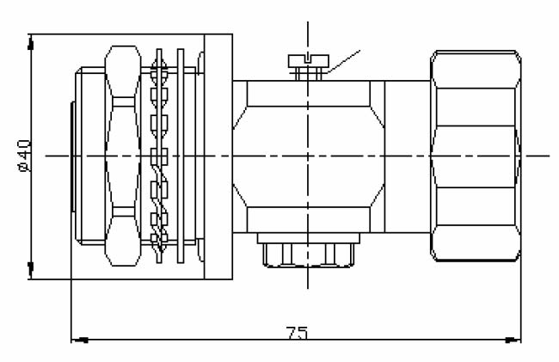
7/16 Male to 7/16 Female
NO. | Name of parts |  | Material (Code) |  |  | Plating
1 |  | Connecting Nut |  | Brass rod (HPb59-1) | Tri-metal plating
2 |  | Shell |  | Brass rod (HPb59-1) | Tri-metal plating
3 |  | Inner Conductor |  | Brass rod (HPb59-1) | Silver plating
4 | socket contact |  | Bronze rod(QSn6.5-0.1) |  |  | Silver plating
5 | pin contact |  | Brass rod (HPb59-1) |  |  | Silver plating
6 | Airproof Gasket |  | silicone rubber |  |  | －
7 | Insulator |  | polytetrafluorethylene (SFX-1) |  |  | －
8 | standard parts |  | Stainless Steel |  |  | －

Impedance |  |  | 50Ω
Contact resistance(normality) | Inner conductor |  | ≤0.4mΩ
Contact resistance(normality) |  | Outer conductor | ≤0.2mΩ
Insulation Resistance (normal) |  |  | ≥1x104MΩ
AC(V /min)Withstanding Voltage |  |  | @ 4000V/1min  No breakdown and no arcing phenomenon
Frequency Range (MHz) |  |  | DC-2600MHz
V.S.W.R. |  |  | ≤1.20
Insertion Loss(dB) |  |  | ≤0.25
Rated Power |  |  | 200
Initial discharge voltage(V) |  |  | 90/150/230/350 (Available)
Peak discharge voltage(V @1×40μS） |  |  | 1000
Peak discharge current (KA) |  |  | 10/20
Weatherproof Rage |  |  | IP66
Intermodulation(PIM3) |  |  | ≤-155dBc
Net Weight (g) |  |  | 290

