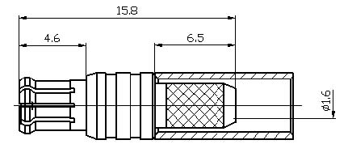
MCX Male Straight Crimp Connector For RG316 Cable
Interface
According to |  | IEC 61169-36;CECC 22220
Electrical
Characteristic Impedance |  | 50 ohm
Frequency Range |  | DC-6GHz
VSWR |  | ≤1.20@DC-3GHz
Dielectric Withstanding Voltage |  | ≥750V RMS,50Hz,at sea level
Dielectric Resistance |  | ≥1000MΩ
Contact Resistance |  | Center Contact ≤5mΩ
 |  | Outer Contact ≤2.5mΩ
Mechanical
Durability |  | Mating cycles ≥500
Material and plating
 | Material | Plating
Body | Brass | Au
Insulator | PTFE | －
Center conductor | Phosphor bronze | Au
Resilient Contact | Phosphor bronze | Au
Ferrule | Annealed Copper | Ni or Au
Gasket(O-ring) | Silicone Rubber | －
Environmental
Temperature Range |  | -40℃～+85℃
RoHs Compliant

